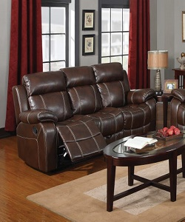

Brown Leather motion sofa

$71.89

Availability: In stock

Description

Soft leather keeps it durable and brings classic style. Stands nearly 23 width to work as the perfect sofa in any room. Added shelf at the base is perfect for sitting place. Different colors available right choice for future durable and beautiful.